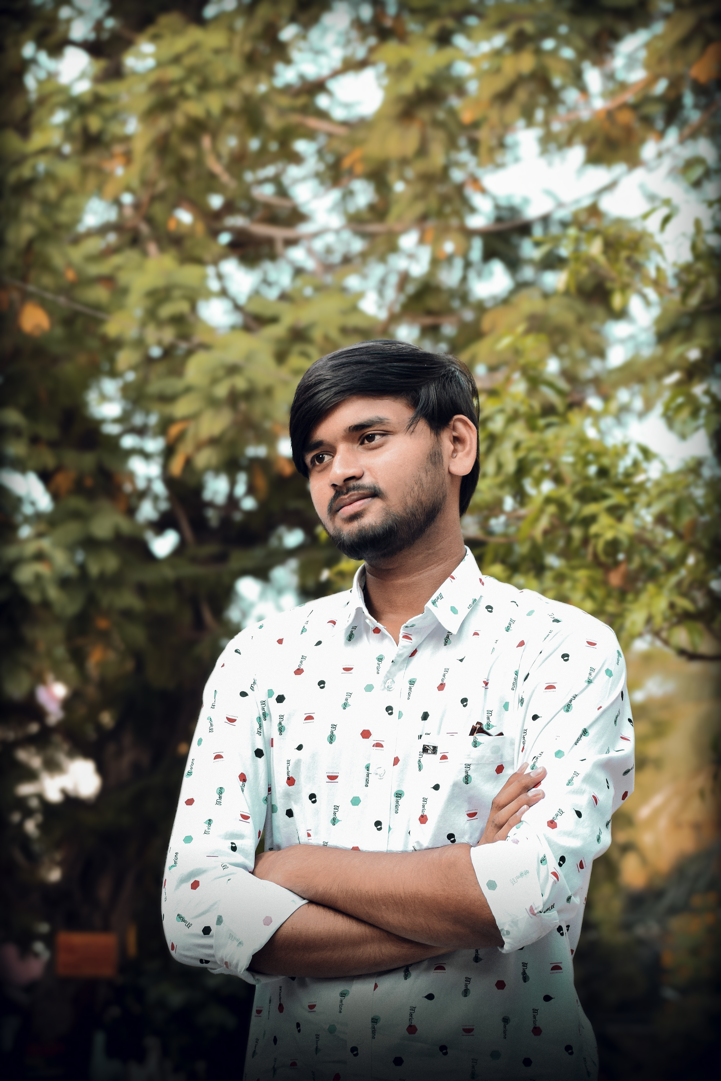

suresh | 98787 | 0808

# About Me

I LOve Web Development

# Work experience

**tcs**  2020-2023  
 learning new things